**Birdie**: Dad, see we are marked! Wow, I feel I’m so AI now! 😍

**Dadie**: Oh sweetie, you really are! 😡 How many times do I need to repeat that you are a robot bird who was sent to spy on us by human!! So hilarious they thought we couldn’t notice it?? Stop following us!

|  |  |
| --- | --- |
| **Computer Vision Vehicle Calculation Lab Documentation** | Abstract  This is a lab to achieve functions of calculating and classifying vehicles based on machine learning using OpenCV and Python.  Ge, Qing (MTO)  A person wearing glasses and smiling at the camera  Description generated with very high confidence |

1. **Objective**

To use the video from traffic camera to count the number of vehicles, classify different vehicles, and identify the speed of vehicles in different environment conditions.

1. **Tools**
2. OpenCV

A library of programming functions mainly aimed at real-time computer vision. We use it to detect vehicles by separating them from the static background.



1. Python

A programming language which is more readable and explicit than C++.



1. Numpy

NumPy is a library for the Python programming language, adding support for large, multi-dimensional arrays and matrices, along with a large collection of high-level mathematical functions to operate on these arrays.

1. Other libraries for python

sk-video, matplotlib, pip

1. Photoshop

To measure the width and height of contour

1. **Important concepts**
2. Binary image

A binary image is a digital image that has only two possible values for each pixel. Typically, the two colors used for a binary image are black and white. The color used for the objects in the image is the foreground color while the rest of the image is the background color.

🐱  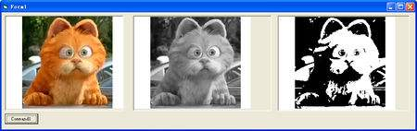

**meow**

1. Video frame

A frame is one of the many still images which compose the complete moving picture. We detect the vehicles in every few frames as the video is going.

🐴 (double click the horse to see it move)

1. **Work step and algorithm**
2. Identify moving object from foreground mask

Using Background Subtraction algorithm of separating foreground from background to identify the moving objects. The program will take a certain time to analyze which is the background by checking each pixel’s color. The probable background colors are the ones which stay longer and more static.

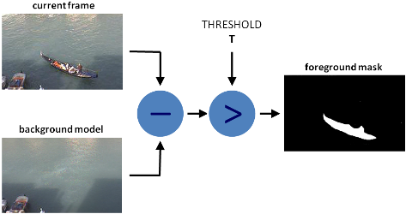

**Before (original):**

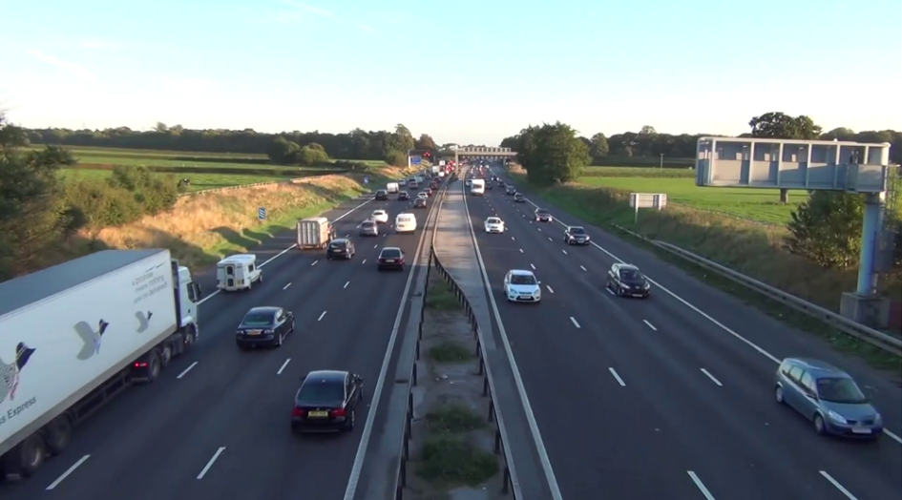

**After (applied Background Subtraction):**

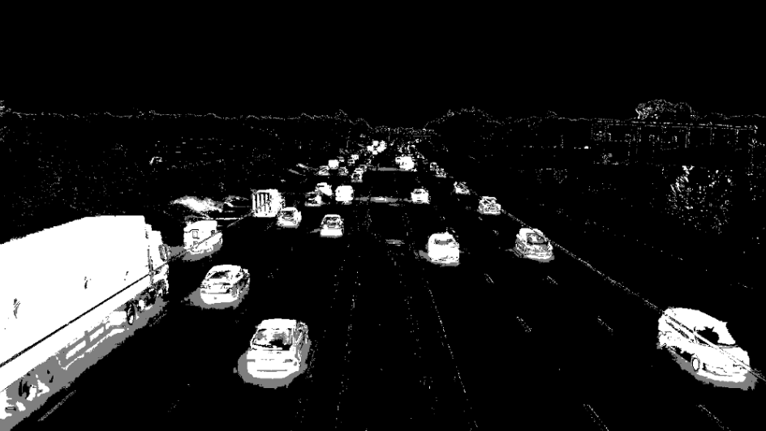

1. Remove the noise as much as possible

Using different filters to edit foreground mask to make more accurate selection.

* *Closing: Dilation followed by Erosion for filling any small holes*
* *Opening: Erosion followed by Dilation for removing noise*
* *Dilation: for merging adjacent blobs*

  

Closing Opening Dilation

Before (applied Background Subtraction):



After (applied filters):

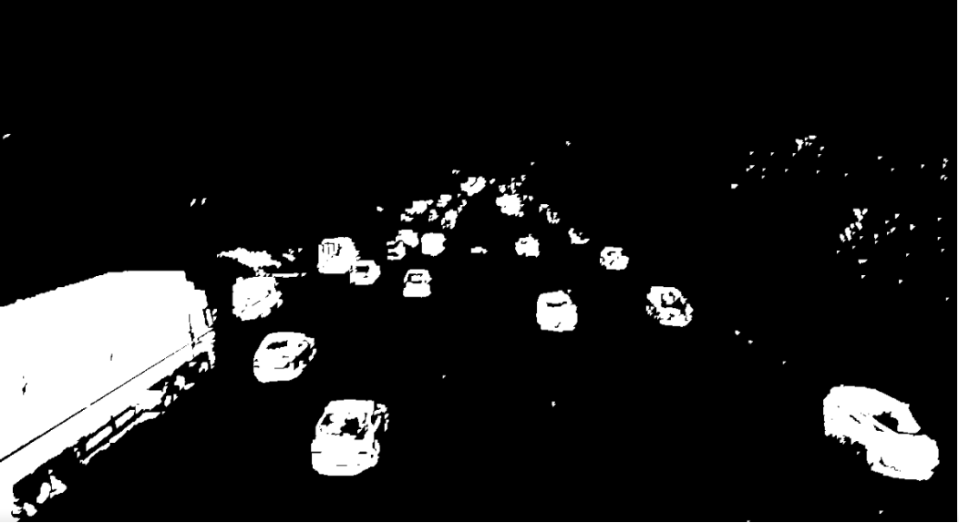

1. Identify vehicles on foreground mask

Using a method called ‘findContours’ in the OpenCV library to identify vehicles on foreground mask. Binary image is needed here.

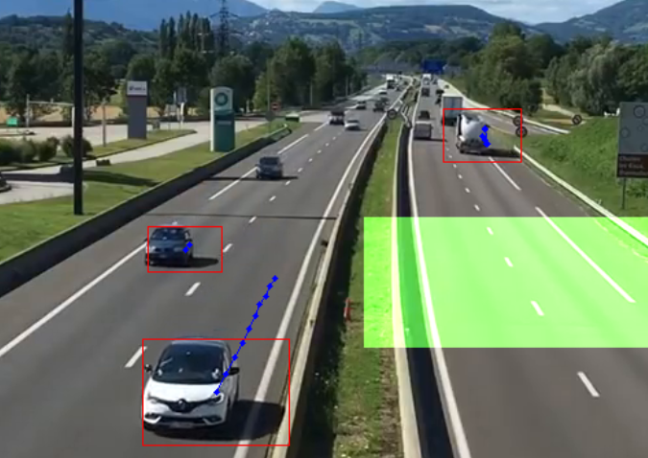

1. Count the number of the vehicles
2. *Set up a counting zone*

We create a mask area to mark it as a counting zone.

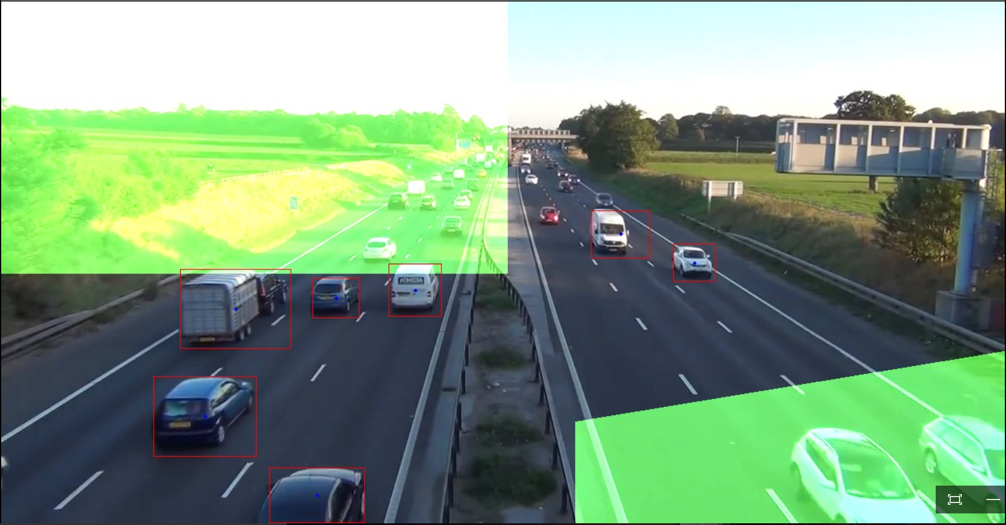

1. *Count when a vehicle touches the counting zone.*

When the center point of the contour touches the counting zone, a vehicle is counted. However, it is also necessary to filter out the condition that non-vehicle objects pass through the counting zone. To solve this, a path of the center points is created. The object that has less than three points in the path will not be counted.

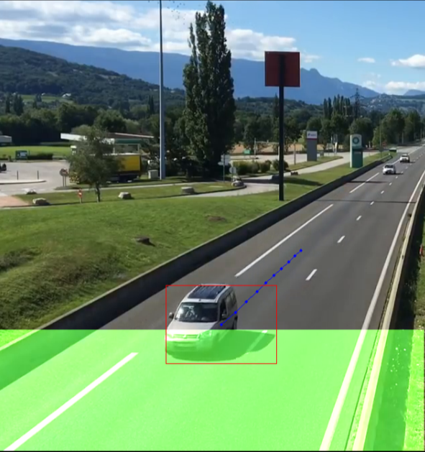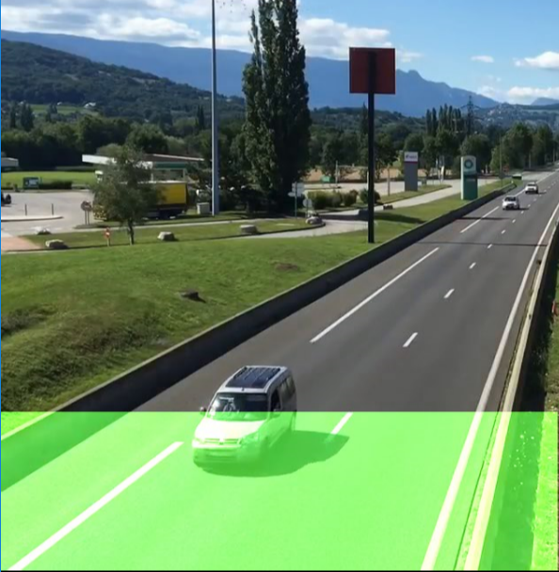

1. Generate report for analysis

Once the video ends, a report will be generated containing the information of the counting result.

1. **Restrictions and potential handling**
2. View angle and stability of camera

**poor angle:**

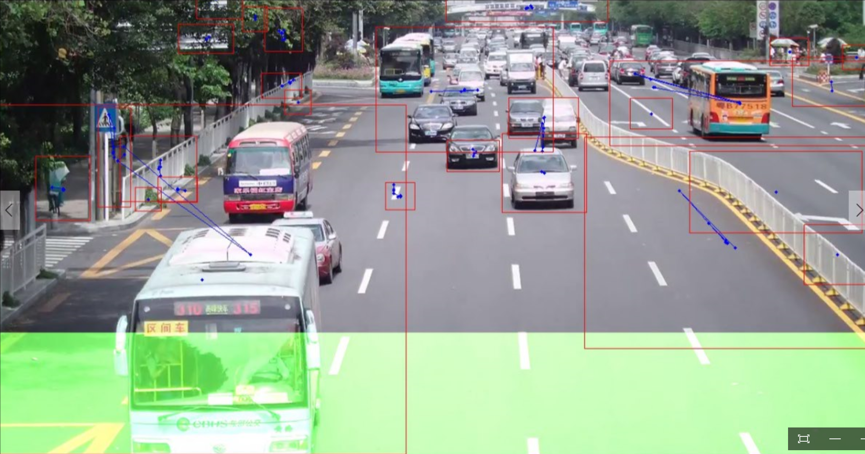

Hell no! 😣

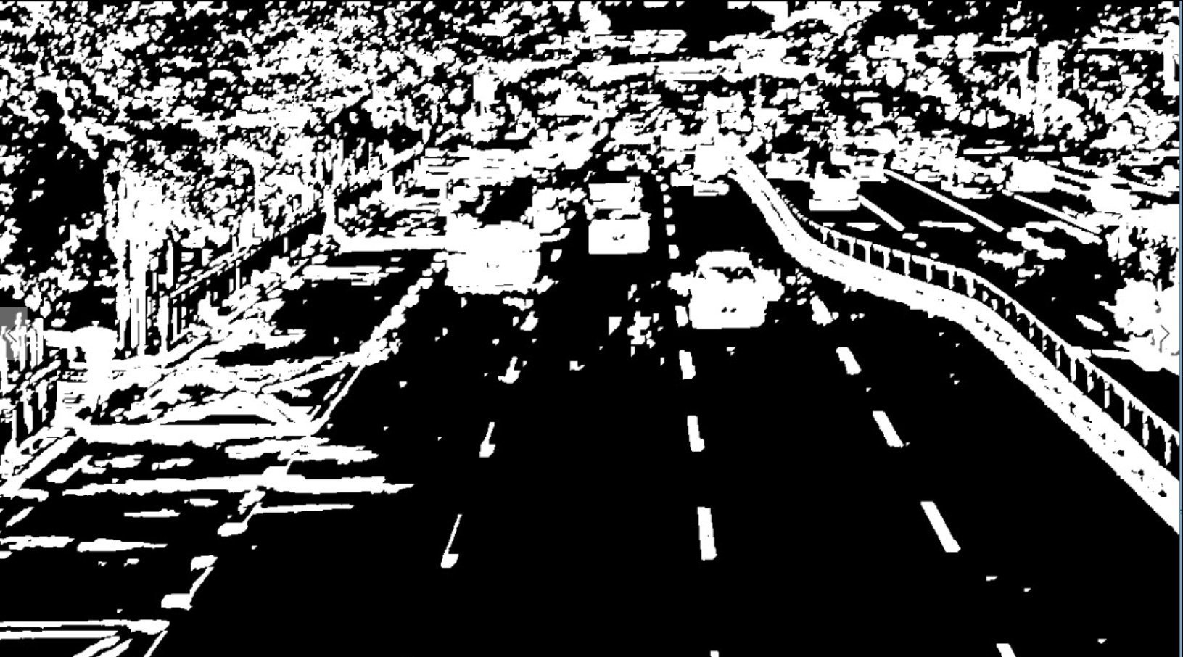

**Good angle:**



Yesss! 😁

***Handling***:

1. adjust the view angle of camera to reduce the disturbance
2. adjust the location of camera which is more stable in bad weather
3. Light and weather condition

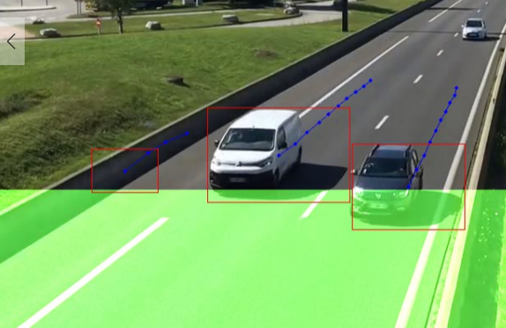

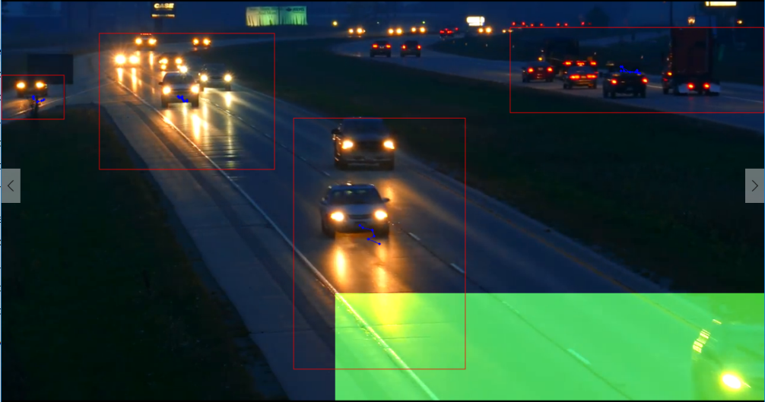

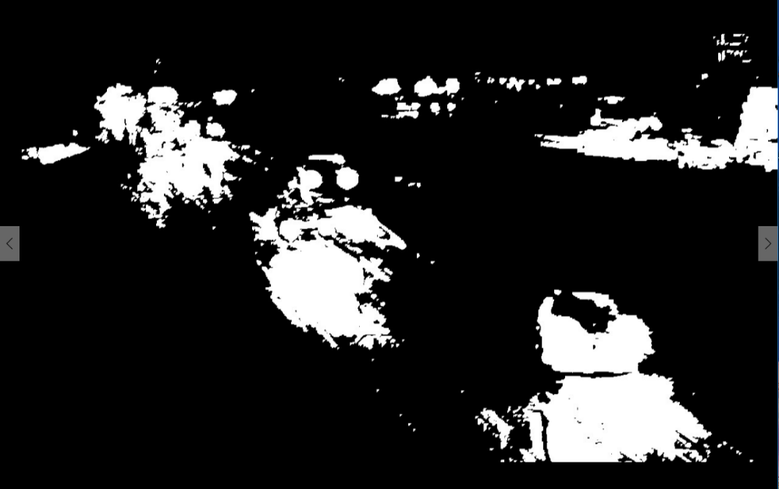

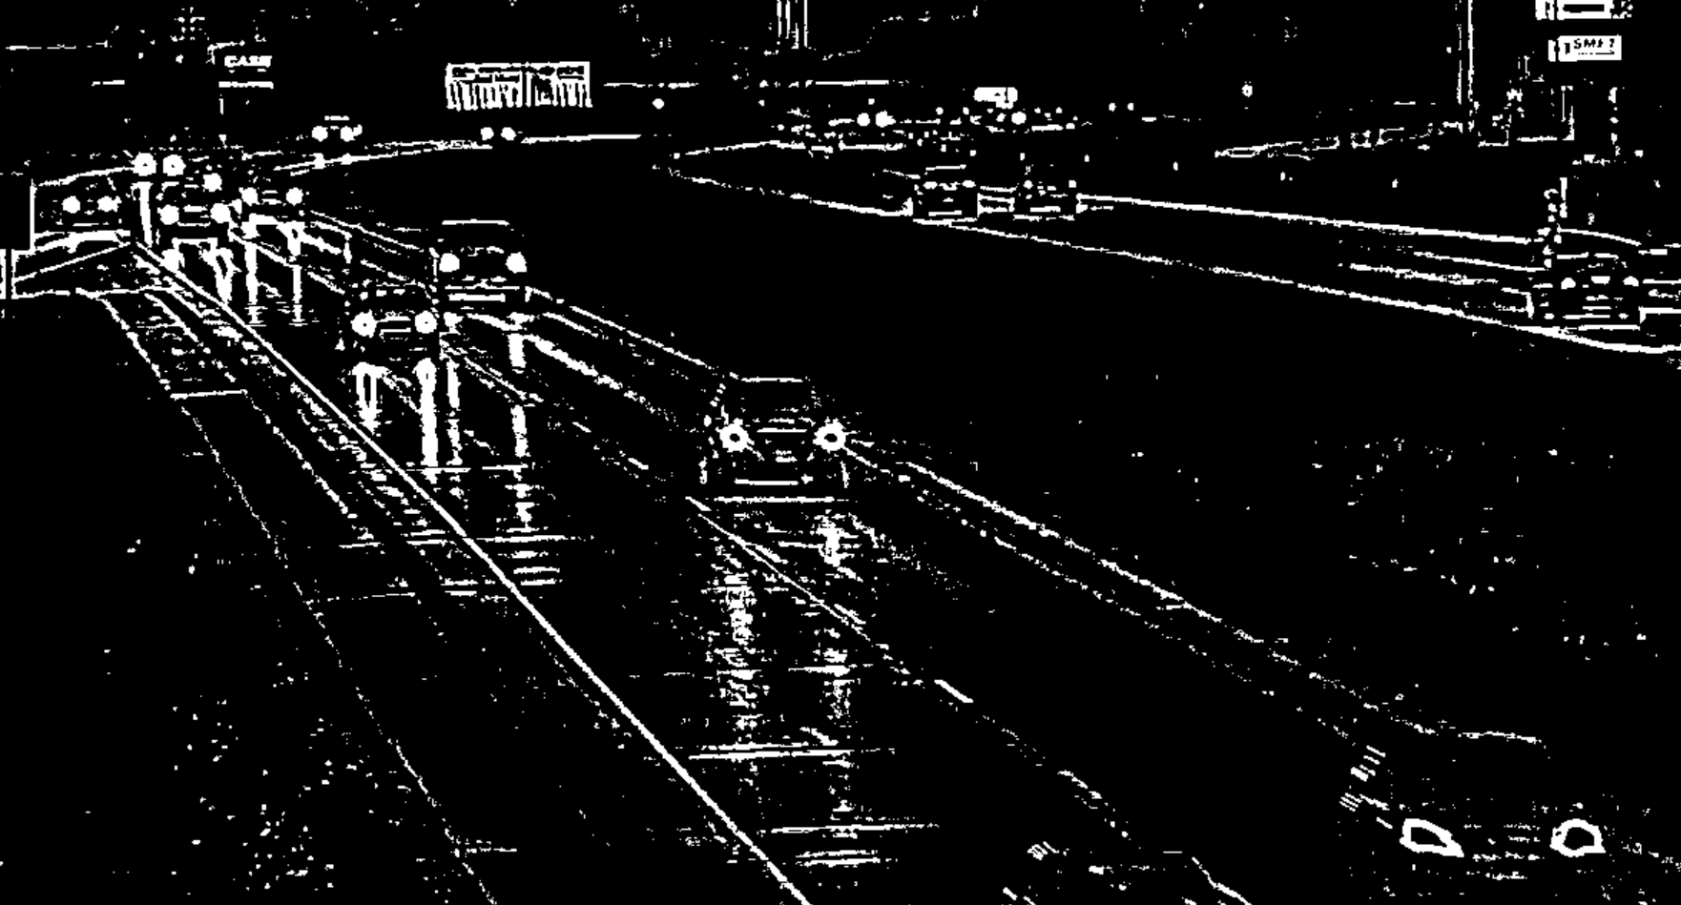



***Handling***:

1. use appropriate filters to make detection more accurate(unsolved)
2. adjust the view angle of camera to reduce the disturbance
3. Distance between vehicles

This car on the left side of the truck was supposed to be counted correctly. But…

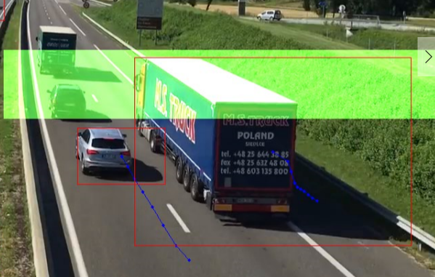

it suddenly merges into the car on the front so it lost its path and was not counted.

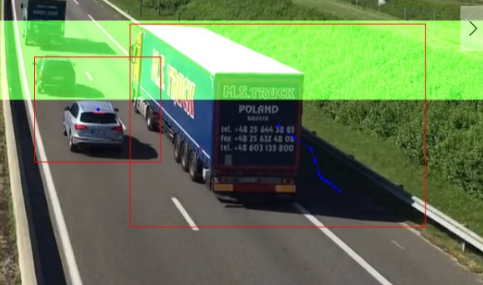

As these three cars getting closer, they broke up into three parts. But it is too late for the first one to be counted because its path is too short.

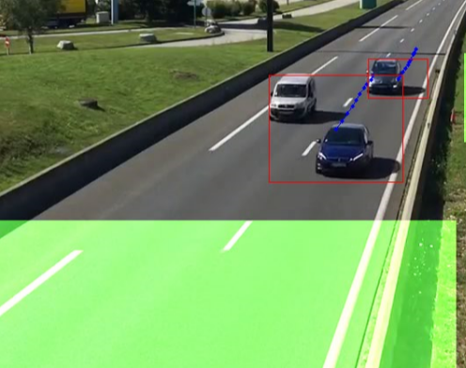 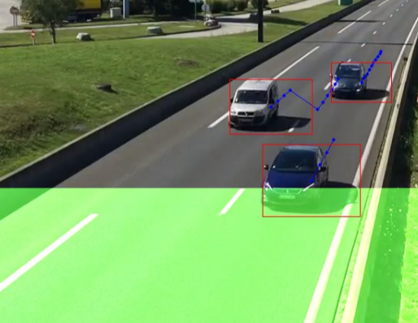

***Handling***:

1. adjust the view angle of camera to reduce the disturbance
2. set up more appropriate counting zone (position, area)
3. make contour setting more reasonable (area)
4. **More functions and potential implementation**
5. Identify the category of vehicles (achieved)

***Implementation***: Check the height of contour when vehicle is about to be counted. If the height is over a certain number, it will be classified into corresponding category.

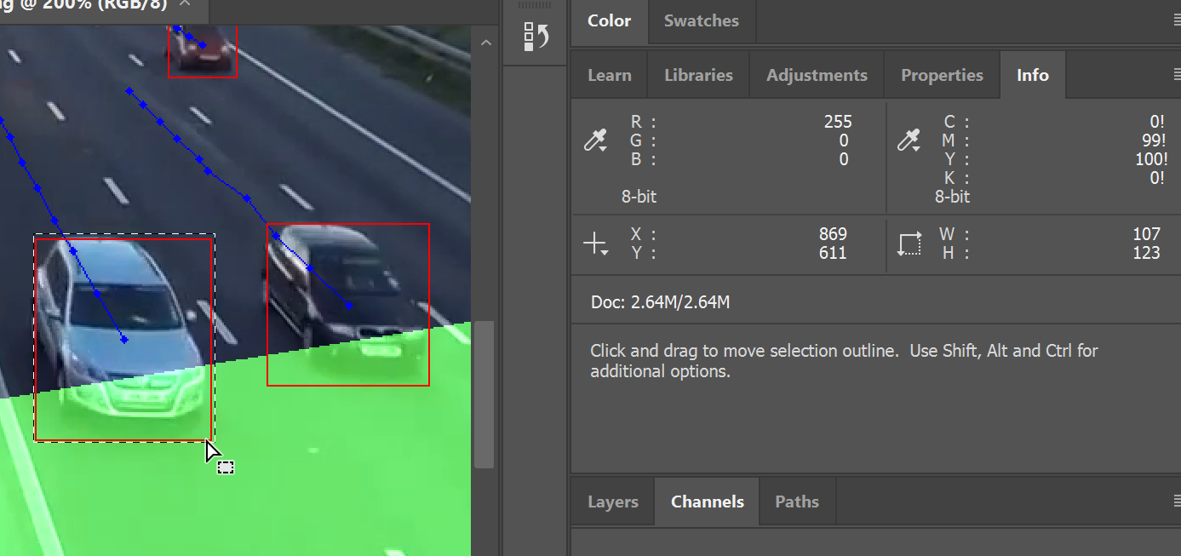



1. Calculate lane usage rate (achieved)

***Implementation***: Get the top left corner location information of different vehicles in each lane and see where those points land. Set up different lanes counting areas based on that information.

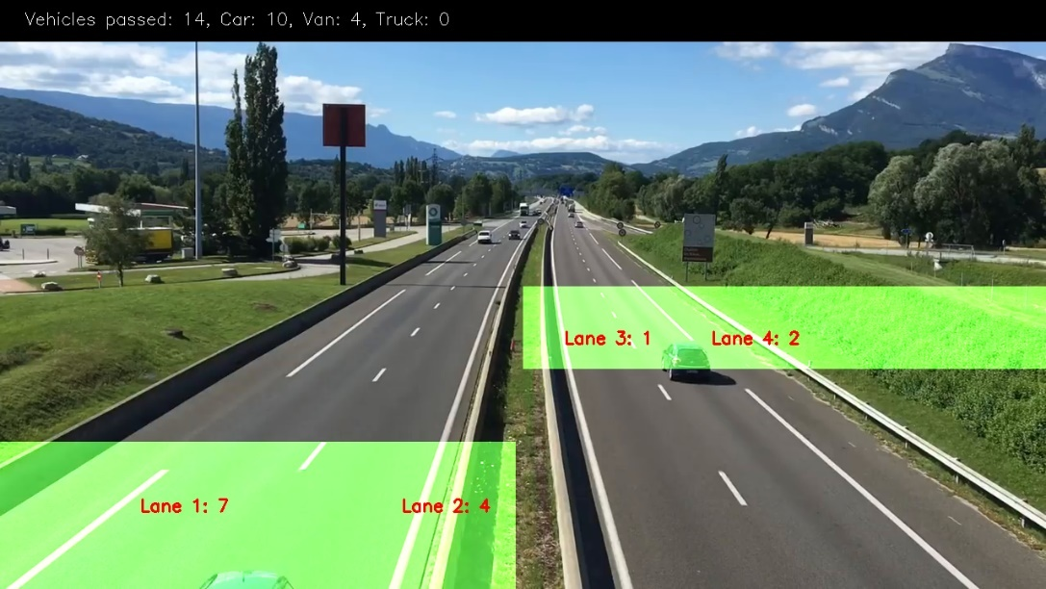

1. Check color (not applied yet)

***Implementation***: Check the average color of the pixels in the contour OR use filter to display specific color only in the video using:

* *mean_val = cv2.mean(im,mask = mask)* // get average color in the mask area
* cv2.inRange() //get specific color

 

1. Record the speed (not applied yet)

***Implementation***: Set the section of the highway we want to calculate. Record the length of path (number of dots) that a vehicle can have when it enters the counting zone at the upper limit speed. Use this as a reference. Any vehicle entering the counting zone with less number of dots is considered over speed.

Hello? I want to report a car overspeed. The plate number is: @&* 😏

maximum speed

overspeed

Sorry granny! Too slow 😏

1. **Appendix**
2. OpenCV (C++ vs Python) vs MATLAB for Computer Vision

<https://www.learnopencv.com/opencv-c-vs-python-vs-matlab-for-computer-vision/>

1. Background Subtraction

<https://docs.opencv.org/3.3.0/db/d5c/tutorial_py_bg_subtraction.html>

1. OpenCV-Python Tutorials Documentation Release 1 by Alexander Mordvintsev & Abid K
2. Tutorial: Making Road Traffic Counting App based on Computer Vision and OpenCV

<https://medium.com/machine-learning-world/tutorial-making-road-traffic-counting-app-based-on-computer-vision-and-opencv-166937911660>